Made by: Parv Garg

Class: 11-A

Term-2 Practicals

Submitted to: Sheela Kale Mam

Question no. 1:-

Write a program using string function.

Solution-

n=raw_input("Enter your name:-")

a=raw_input("Enter the string:-")

b=raw_input("Enter the string to be searched:-")

x=n.capitalize()

def string0():

print"1. in range Operator"

print"2. not in range function"

print"3. Concatenation Operator"

print"4. Replication Operator"

print"5. Unicode Operator"

ch=input("Enter your choice:-")

if ch==1:

print a in b

if ch==2:

print a not in b

if ch==3:

print a + b

if ch==4:

num=input("Enter the number:-")

print"1. To get Replication of First String your choice is 1"

print"2. To get Replication of Second String your choice is 2"

c=input("Enter your choice:-")

if c==1:

print a*num

else:

print b*num

if ch==5:

print "To get unicode of First String------1"

print "To get unicode of Second String------2"

e=input("Enter your choice:-")

if e==1:

l=len(a)

for i in range(0,l):

print"The Unicode of",a[i],"is:-",ord(a[i])

else:

r=len(b)

for j in range(0,r):

print"The Unicode of",b[j],"is:-",ord(b[j])

print

print n,"Do you want to continue??"

print" To continue Program your choice is 1"

print" To end the Program your choice is 2"

h=input("Please enter your choice:-")

if h==1:

string0()

else:

exit()

string0()

def thanks():

print "\n","\n","Made by Parv Garg, 11th-A","\n","Submitted to Sheela Kale Mam","\n","Thanks for using me","\n","#######################End#######################"

Output:-

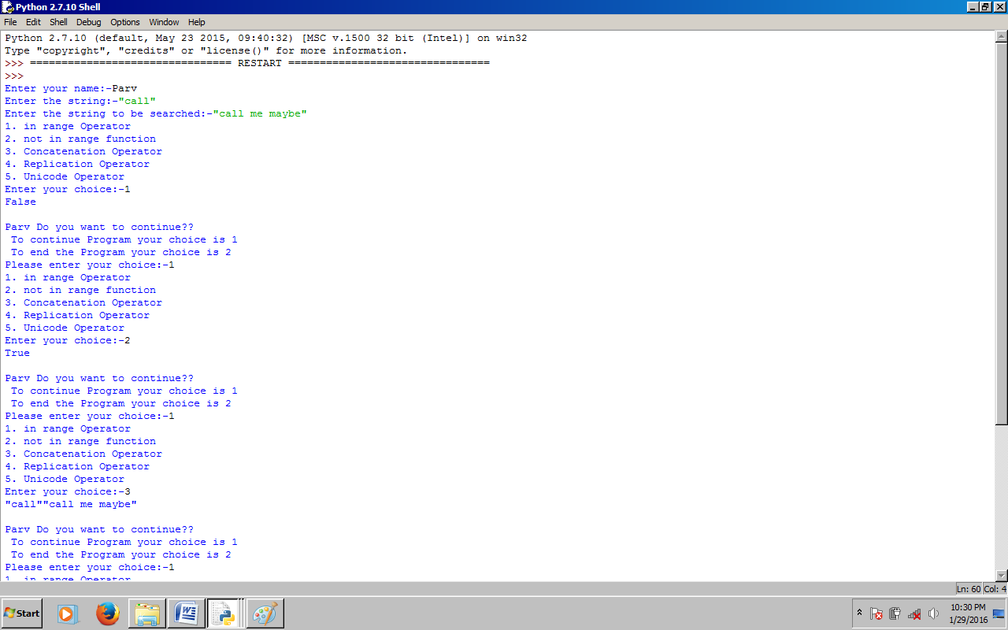 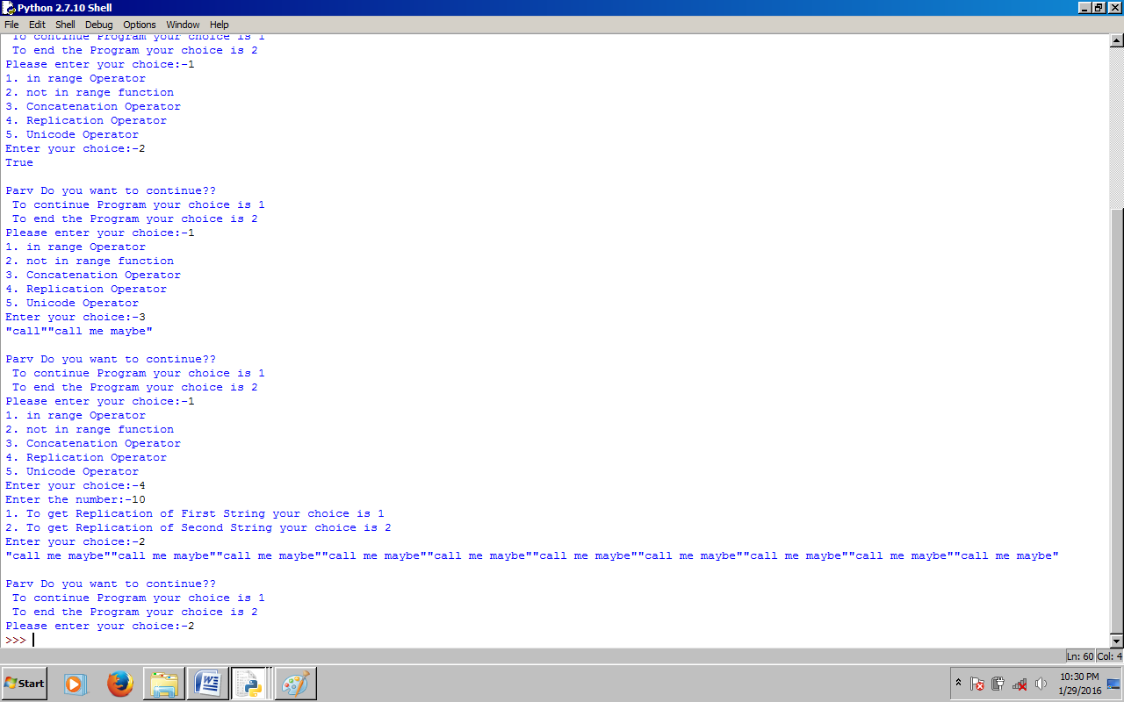

Question no. 2:-

Capitalize the first letter of all words.

Solution-

import string

def thanks():

print "\n","\n","Made by Parv Garg, 11th-A","\n","Submitted to Sheela Kale Mam","\n","Thanks for using me","\n","#######################End#######################"

n=raw_input("Enter your sentence:-")

r=len(n)

print n[0].upper(),

for i in range(1,r):

if n[i].isspace()==True:

print n[i],

print n[i+1].upper(),

if n[i].isspace()==False:

if n[i-1].isspace()==False:

print n[i],

thanks()

Output:-

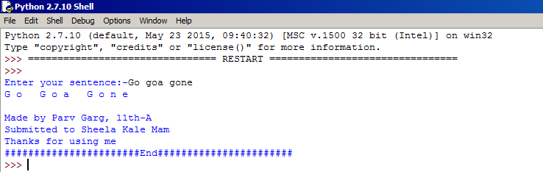

Question no. 3:-

Extract two list-slices out of a given list of numbers. Display and print the sum of elements of first list-slices which contains every other element of the list between indexes 5 to 15. Program should also display the average of elements in second list slice that contains every forth element of the list. The given list contains number from 1 to 20.

Solution-

lst=[1,2,3,4,5,6,7,8,9,10,11,12,13,14,15,16,17,18,19,30]

def thanks():

print "\n","\n","Made by Parv Garg, 11th-A","\n","Submitted to Sheela Kale Mam","\n","Thanks for using me","\n","#######################End#######################"

slc1=lst[5:15:2]

slc2=lst[::4]

sum=0

avg=0

print "Slice 1"

for a in slc1:

sum+=a

print a,

print

print "Sum of elements of slice 1:",sum

sum=0

for a in slc2:

sum+=a

print a,

print

avg=sum/len(slc2)

print "Average a elements of slice 2:",avg

thanks()

Output:-

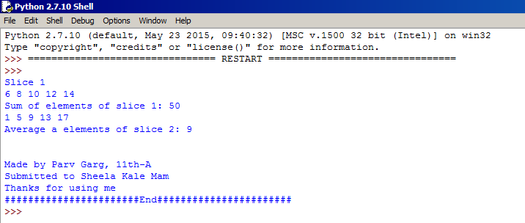

Question no. 4:-

Program to perform various list operation after displaying menu.

Solution-

ch=0

list=[]

while True:

print"List Manipulation Menu"

print"1. Add Element(s)"

print"2. Modify Element"

print"3. Delete Element"

print"4. Sort List"

print"5. Display List"

print"6. Exit"

c=int(raw_input("Enter your choice:-"))

if c==1:

print"1. Add Element"

print"2. Add List"

r=raw_input("Enter your choice 1 or 2:-")

if r==1:

i=raw_input("Enter the Element to be added:-")

p=raw_input("Enter the position:-")

list.insert(p,i)

else:

h=raw_input("Enter the list to be added:-")

list.extend(h)

print"Successfully Added"

if c==2:

p=raw_input("Enter position where to be added:-")

i=raw_input("Enter new value for element:-")

o=list[p]

list[p]=i

print o,"modified with value",i

if c==3:

print"1. Delete element by position"

print"2. Delete element by value"

r=raw_input("Enter your choice 1 or 2:-")

if r==1:

p=raw_input("Enter position where to delete:-")

i=list.pop(p)

print i,"deleted"

else:

i=raw_input("Enter element to be deleted:-")

p=list.remove(i)

print "Successfully Deleted"

if c==4:

print"1. Ascending"

print"2. Descending"

r=raw_input("Enter your choice 1 or 2:-")

if r==1:

list.sort()

else:

list.sort(reverse=True)

if c==5:

print list

if c==6:

break

else:

print "Valid choices are 1 to 6.."

def thanks():

print "\n","\n","Made by Parv Garg, 11th-A","\n","Submitted to Sheela Kale Mam","\n","Thanks for using me","\n","#######################End#######################"

thanks()

Output:-

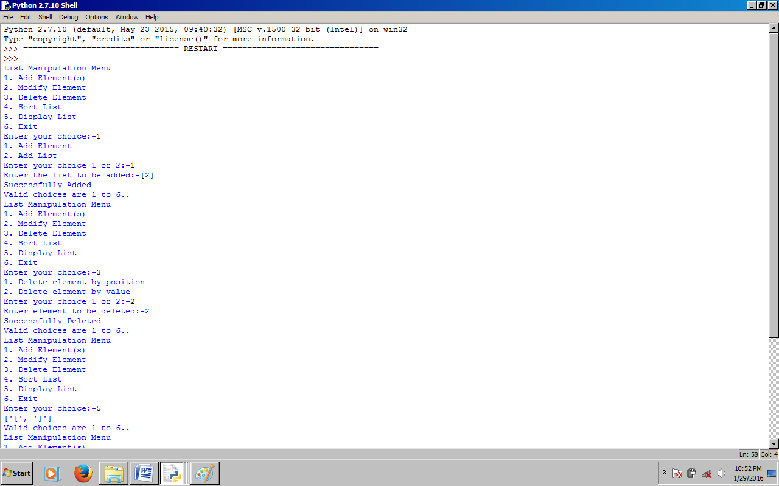 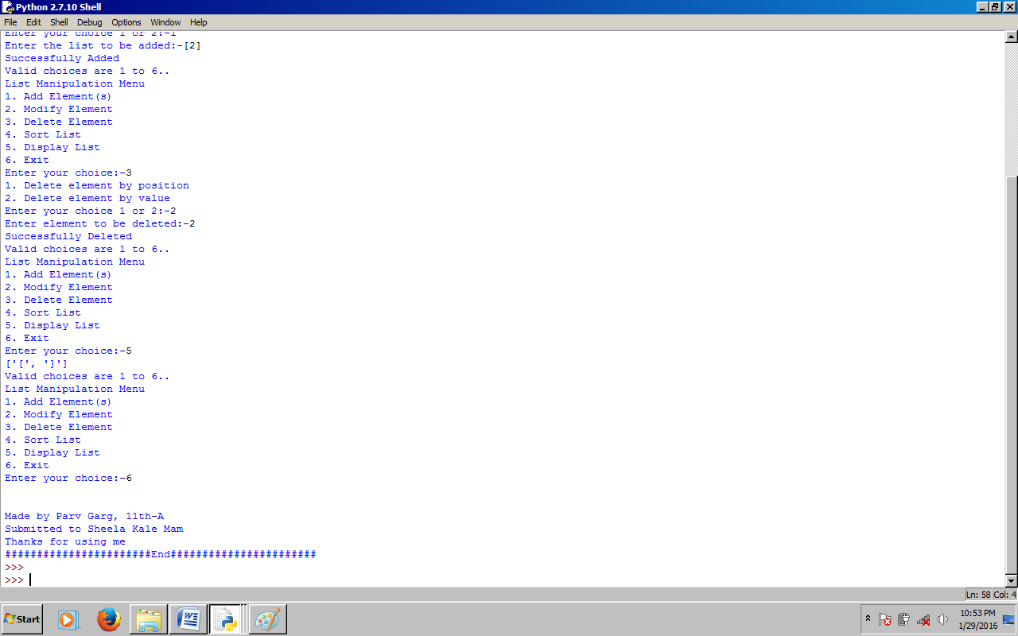

Question no. 5:-

Program that read a line and prints its statistics like:

Number of uppercase letters:

Number of lowercase letters:

Number of alphabets:

Number of digits:

Solution-

s=raw_input("Enter a String:-")

def thanks():

print

print

print "Thanks for using me"

print "Made by Parv Garg, 11th-A"

print "Submitted to Sheela Kale Mam"

print "#######################End#######################"

lc=uc=d=al=0

for a in s:

if a.islower():

lc+=1

elif a.isupper():

uc+=1

elif a.isdigit():

d+=1

if a.isalpha():

al+=1

print "Number of uppercase letters:",uc

print "Number of lowercase letters:",lc

print "Number of alphabets:",al

print "Number of digits:",d

thanks()

Output:-

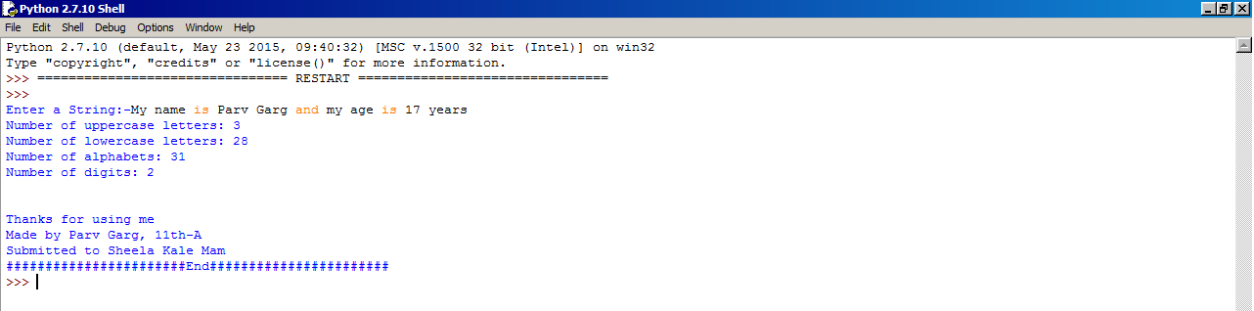

Question no. 6:-

Program that read a line and a substring. It should then display the number of occurrence of the given substring in the line.

Solution-

l=raw_input("Enter a line:")

s=raw_input("Enter a sub-string:")

def thanks():

print "\n","\n","Made by Parv Garg, 11th-A","\n","Submitted to Sheela Kale Mam","\n","Thanks for using me","#######################End#######################"

lenl=len(l)

lens=len(s)

start=0

end=lenl

count=0

while True:

pos=l.find(s,start,end)

if pos<>-1:

count+=1

start=pos+lens

else:

break

if start>=lenl:

break

print "No of occurance of",s,":",count

thanks()

Output:-

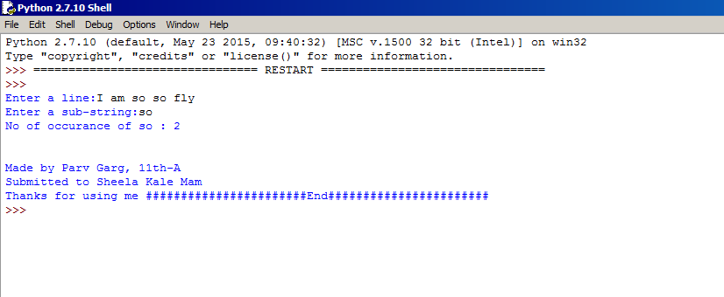

­­

Question no. 7:-

Write a program that read a string and checks whether it is a palindrome string or not.

Solution-

string=raw_input("Enter a string:")

def thanks():

print "\n","\n","Made by Parv Garg, 11th-A","\n","Submitted to Sheela Kale Mam","\n","Thanks for using me","#######################End#######################"

lenght= len(string)

mid=lenght/2

rev=-1

for a in range(mid):

if string[a]==string[rev]:

a+=1

rev-=1

else:

print string,"is not a palindrome"

break

else:

print string,"is a palindrome"

thanks()

Output:-

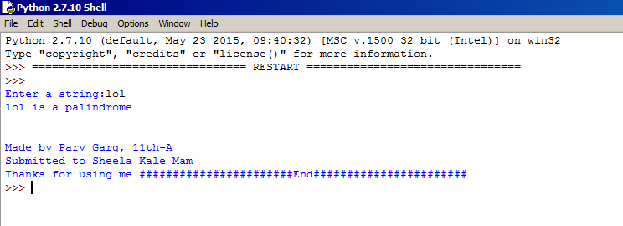

Question no. 8:-

Write a program that reads a string and then prints a string that capitalize every other letter in the string e.g., passion becomes pAsSiOn

Solution-

string=raw_input("Enter a string:")

def thanks():

print "\n","\n","Made by Parv Garg, 11th-A","\n","Submitted to Sheela Kale Mam","\n","Thanks for using me","\n","#######################End#######################"

lenght =len(string)

print "Original string:",string

string2=""

for a in range(0,lenght,2):

string2+=string[a]

if a<(lenght-1):

string2+=string[a+1].upper()

print "Alternative capitalized string:",string2

thanks()

Output:-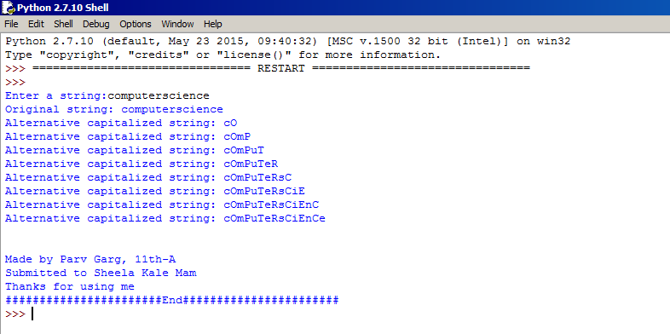

Question no. 9:-

Write a function is_member() that takes a value x and a list of values a, and return True if x is a member of a, False otherwise.

Solution-

def is_member(x,a):

ln=len(a)

for el in range(ln):

if x==a[el]:

return True

return False

x=eval5(raw_input("Enter the string(single character):"))

a=eval(raw_input("Enetr the list:"))

print is_member(x,a)

def thanks():

print "\n","\n","Made by Parv Garg, 11th-A","\n","Submitted to Sheela Kale Mam","\n","Thanks for using me","\n","#######################End#######################"

thanks()

Output:-

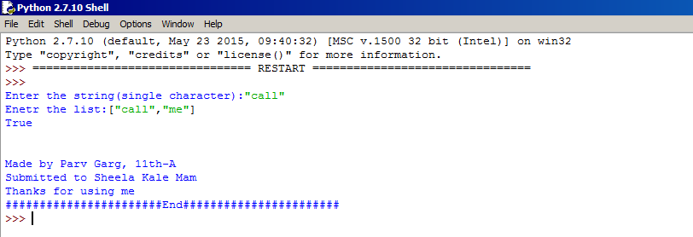

Question no. 10:-

Define a function overlapping() that takes two lists and return True if they have at least one member in common. False other wise.

Solution-

def overlapping(a,b):

l1=len(a)

l2=len(b)

for i in range(l1):

for j in range(l2):

if a[i]==b[j]:

return True

else:

return False

a=eval(raw_input("Enter the main list:"))

b=eval(raw_input("Enter a list which is to be checked in list 'a':"))

print "The result",overlapping(a,b)

def thanks():

print "\n","\n","Made by Parv Garg, 11th-A","\n","Submitted to Sheela Kale Mam","\n","Thanks for using me","\n","#######################End#######################"

thanks()

Output:-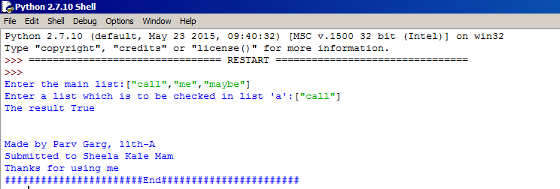

Question no. 11:-

Write a program to create a dictionary names of completion winner students as keys and number of their wins a value.

Solution-

n=int(raw_input("How many students?"))

CompWinner={}

for a in range (n):

key=raw_input("Name of the students:")

value=int(raw_input("Number of competition won:"))

CompWinner[key]=value

print "The dictionary now is:"

print CompWinner

Output:-

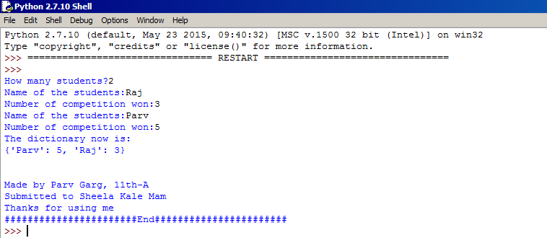

Question no. 12:-

Consider a dictionary my_points with single-letter keys, each followed by a 2-element tuple representing the coordinates of a point in an x-y coordinate plane.

my_points= {‘a’:(4,3), ‘b’:(1,2),’c’: (5,1)}

Write a function to return the maximum value from within all of the values tiples at same index. For example, maximum for oth index will be computed from 4,1and 5 – all the entries at oth index in the value-tuple.

Print the result in the following format:

Maximum Value at index(my_points,0)=5

Maximum Value at index(my_points,1)=3

Solution-

my_points={"a":(4,3),"b":(1,2),"c":(5,1)}

def thanks():

print "\n","\n","Made by Parv Garg, 11th-A","\n","Submitted to Sheela Kale Mam","\n","Thanks for using me","\n","#######################End#######################"

highest=[0,0]

init=0

for a in range(2):

init=0

for b in my_points.keys():

val=my_points[b][a]

if init ==0:

highest[a]=val

init +=1

if val>highest[a]:

highest[a]=val

print "Maximun Value at index(my_points,",a,")=",highest[a]

thanks()

Output:-

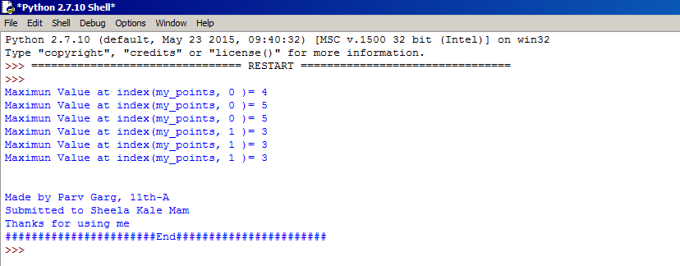

Question no. 13:-

Write a program that creates a tuple storing first 9 terms of Fibonacci series.

Solution-

l=[]

f=0

def thanks():

print "\n","\n","Made by Parv Garg, 11th-A","\n","Submitted to Sheela Kale Mam","\n","Thanks for using me","\n","#######################End#######################"

s=1

for i in range(7):

t=s+f

l=l+[t]

f,s=s,t

v=tuple([0,1]+l)

print v

thanks()

Output:-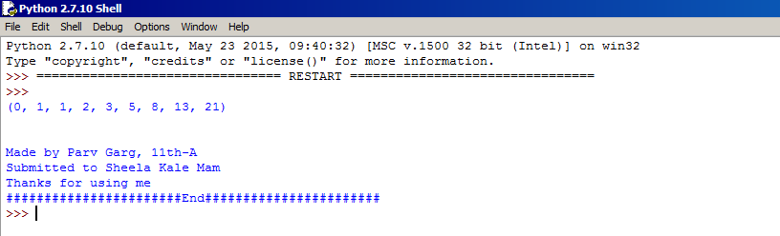

Question no. 14:-

Write a program that repeatedly asks the user to enter the product name and prices. Store all of these in a dictionary whose keys are the product names and whose value are the prices.

Solution-

b=int(raw_input("Enter the number of products"))

def thanks():

print "\n","\n","Made by Parv Garg, 11th-A","\n","Submitted to Sheela Kale Mam","\n","Thanks for using me","\n","#######################End#######################"

dict={}

for i in range(b):

n=(raw_input("Enter the name of product"))

value=int(raw_input("Enter the price of product"))

dict[n]=value

print dict

thanks()

Output:-

